Department of Computer Science and Engineering

University of Nevada, Reno

The CTAR All-Star

Project Part II: Specification

Team #3

Andrew Penrose, Austin Yount, and Terri Heglar

Instructors: Dr. Sergiu Dascalu and Devrin Lee

Advisor: Dr. Frederick Harris

November 2, 2018

## Table of Contents

**Table of Contents** **1**

**Introduction** **2**

**Summary of Stakeholders’ Interviews** **2**

Kristine Galek Ph.D., CCC-SLP 2

Katie Allen, M.S., CCC-SLP 5

Amanda Morrissey, M.S., CCC-SLP 6

**High Level Business Requirements** **6**

**Technical Requirements Specification** **7**

Functional Requirements 7

Non-Functional Requirements 9

**Use Case Modeling** **10**

Use Case Diagram 10

Use Case Descriptions 11

Detailed Use Cases 13

**Requirement Traceability Matrix** **15**

**Initial Snapshots** **16**

**Glossary** **19**

**List of References** **20**

Websites 20

Articles 20

Publications 21

Cited in This Paper 21

**Contributions of Team Members** **22**

Terri Heglar 22

Austin Yount 22

Andrew Penrose 22

## Introduction

Dysphasia is a medical condition that is primarily seen in stroke victims and the elderly. The condition makes the act of swallowing difficult and affects millions of people every year. One current treatment exercise is known as the Chin Tuck Against Resistance or CTAR. This exercise involves squeezing a ball between the chest and chin in order to strengthen the muscles in the neck. The CTAR exercise is effective for rehabilitating dysphasia, but it has been shown that patients are able to perform better and work harder with visual feedback. The CTAR All-Star will be a system consisting of a pneumatic ball with an embedded pressure sensor and a bluetooth transmitter. The system will be coupled via bluetooth with a cross-platform mobile device application. The system will be used in a similar fashion to the CTAR exercise but it will have additional functionality including graphics that show the pressure inside the ball, different exercise modes, and the ability to store and retrieve the results and statistics from an online server. The real time graphics will help both the patient and the medical professional/clinician visually see the pressure reading from the device. As a result of the stakeholders’ interviews, some features were clarified and additional features have been added to the project. These features include incorporating different exercise modules to target isometric and isotonic muscle contractions. It is necessary to include different exercise modes because isometric exercises improve endurance which is important for joint stabilization while isotonic exercises use repetitive muscle shortening and lengthening against resistance which generates more muscle damage and improves strength.

## Summary of Stakeholders’ Interviews

### *Kristine Galek Ph.D., CCC-SLP*

We interviewed Dr. Kristine Galek, an assistant professor at the University of Nevada, Reno’s Medical Department. Dr. Galek is also the Co-Director of the Northern Nevada Voice and Swallow Clinic and Director of the RAVSS Research Laboratory. Dr. Galek was our first choice for an interview, since she is our client and the originator of our project idea. We asked Dr. Galek the following questions:

|  |  |
| --- | --- |
| 1. | How would your profession benefit from this project? |
| 2. | What in your view would make this a successful project? |
| 3. | What functions are desired? |
| 4. | What is the priority of each feature or function? |
| 5. | What are the business requirements? |
| 6. | What results are required/desired? |
| 7. | What are the metrics to define success? |
| 8. | Are there any other requirements we should be aware of? |
| 9. | Are there any products/projects related to this one? |
| 10. | Is there anything we didn’t discuss? |

Additionally. we asked Dr. Galek some more specific questions about the project to gather more details and better understand her expectations. The questions were as follows:

|  |  |
| --- | --- |
| 11. | What is the current process? |
| 12. | What type of exercises would this project be used for? |
| 13. | What kind of people will the primary users be? |
| 14. | What are the pitfalls/what is inhibiting success with the current process? |
| 15. | What’s been done to solve this already? |
| 16. | How much history would you like stored & who should have access to it? |
| 17. | What level of security is required? |
| 18. | What kind of training do you anticipate needing? |
| 19. | How would you like to be involved in the rest of the project, and what’s the best way to reach you? |
| 20. | Is there anyone we need to speak with who isn’t on our list? |

We spoke to Dr. Galek in person for about an hour. The following is a summary of our conversation in which we asked our questions mainly as they came up in conversation. She spoke about the need for an effective way to measure the results of the chin tuck against resistance exercise. Currently, they have no way of knowing if the patient is actually putting any amount of force into the exercise. With proper measuring techniques, they can gather better data for research and determine if the exercise is indeed an effective rehabilitation technique.

Dr. Galek said her profession would benefit in several ways from this project. It will help speech pathologists know more about swallowing conditions and rehabilitating them. Additionally, it will help a speech pathologist give more specialized treatment to patients. She also said several times that patients perform better with visual feedback.

Several of our questions asked about the metrics for success in our project. Dr. Galek suggested she would consider us successful if we had a working product, done in time for the “symposium”. She would also like us to make it to market and write an article, ideally published.

The business requirements she spoke about are a product that works and works reliably. Data gathered from the device should be replacatable and precise. She would also like the price point to be low enough that a patient can pay cash for it, no more than $200 dollars, making it affordable and accessible. This price would not include the phone or tablet required to run the application.

The functions she would like the project to encompass are a visualization of the exercises, a way to set thresholds, a hold time with a target, and a repetition counter. She would like separate training and exercise modules, with different modules for isometric and isotonic exercises. She would also like the visualization neutral enough to appeal to multiple demographics, although a large part of our users will be older and many of them under long term care.

As for security, Dr. Galek said as long as we are careful with the information our application stores, we shouldn’t need to worry about HIPAA requirements. Essentially, we can’t use any identifying information. She said we can use their medical records number for our application, and can upload a pdf or histogram to their electronic medical record (EMR).

Currently, there are no competitors in the CTAR exercise devices. However, there are several for similar rehabilitation exercises. These exercises include sEMG, surface electromyography, with the leading competitor being Synchrony by ACP (Accelerated Care Plus), and an exercise that strengthens the tongue using a bulb, which is led by IOPI Medical. Both of these companies have effective ways to measure rehabilitation results and somewhat interactive visualizations.

In closing our interview, Dr. Galek expressed that she would like to meet with us once a month to stay in the loop and keep us on track. It will also be an opportunity for us to ask any needed questions. We will begin these meetings in December, as her November schedule is very busy. She also suggested some areas for us to research, including Neuroplastic principles, CTAR, and IOPI. Additionally, she put us in touch with some colleagues she thought would be willing to speak with us.

### *Katie Allen, M.S., CCC-SLP*

Following Dr. Galek’s suggestion, we interviewed Katie Allen, a graduate research assistant at the University of Nevada, Reno. Katie works as a clinician for the Northern Nevada Voice and Swallow Clinic. She treats patients with dysphagia and will be a user of our product when it is available, which makes her a good person to interview. We asked her the same first ten questions we asked Dr. Galek. We interviewed Katie via email and the following is a summary of her answers.

Like Dr. Galek, Katie expressed the need for a measurable system, to broaden their understanding and research, which will lead to improved patient outcomes. She said they currently use a rolled-up towel or an inflated ball under the chin. They have no way to quantify the resistance. They also cannot change that resistance

Her measurement of our success is if we are able to create something that she will be able to use in practice. Integrating a way to change the resistance would be helpful as well. As for business requirements, she suggests that it has to be portable and cost effective, and depending on our target audience, the cost can vary.

The primary function Katie Allen would like to see is a way to measure how much pressure the patient is exerting. In addition to measurement, she is interested in knowing what level of pressure a healthy person is capable of exerting as a baseline. Some additional functionality requirements are portability , accuracy, data storage, visual representation, and sterilizability or disposable parts to prevent spreading of infections. She also commented that we need to consider the constant changes of the medical field. We should be able to easily update our software, possibly remotely, when the products are out in the field.

### *Amanda Morrissey, M.S., CCC-SLP*

We chose to interview Amanda because she is a colleague of Dr. Galek and a Lecturer in Speech Pathology and Audiology at the University of Nevada, Reno. She is a clinician at the Northern Nevada Voice and Swallow Clinic, which makes her an ideal candidate to interview. We gathered her answers via email and asked her questions 1-10.

Amanda expressed that her profession would benefit from this device because it would allow them to integrate additional objective data into their rehabilitation program. She would like the device to measure pressure and provide visual feedback as well as track duration. She would consider us successful if we can achieve these functionalities.

For business requirements, Amanda said the most important thing to consider is cost. The product should be inexpensive so that each patient can purchase one. If we aren’t able to keep the cost down, we should incorporate materials that are tolerant to a high level of disinfecting or integrate the use of disposable covers.

Ms. Morrissey mentioned that there is research and data that support the use of the CTAR ball, and there is an ideal size for the ball that we should look into. She is unaware of any competitors that quantify the pressure component.

## High Level Business Requirements

There are a few foreseeable requirements that are necessary to create a successful business. The first being product accessibility. For this device to be successful, it needs to be affordable. Dr. Galek stated that the patient should be able to pay cash for this device. A price point of $200, or less, should be affordable for patients to have their own personal device for home use. A major factor affecting the price point of the device will be whether or not the device uses a disposable piece for each patient, or if it is sterilized after each use.

Next, the device needs to be reliable. This means the sensors and sensor readings need to be accurate. The device should be able to produce the same data from a sample testing every time. From a business standpoint, if the device is not returning reliable data, then it cannot be used in the industry.

The application has to be user friendly. The target market for this device can range from children to elderly patients. To combat user inexperience, the application needs to be easy to navigate and laid out both logically and efficiently. A user should not have to wade through multiple pages to reach a feature in the application.

The purpose of this application is to give patients and medical professionals a way to track dysphagia rehabilitation progress. There are current rehabilitation exercises, but there is not a way to measure if they are working or not. This application will provide that knowledge.

## Technical Requirements Specification

### *Functional Requirements*

|  |  |  |
| --- | --- | --- |
| FR1 | [1] | The CTAR All-Star shall store a user profile. |
| FR2 | [1] | The CTAR All-Star shall identify users only by EMR numbers. |
| FR3 | [1] | The CTAR All-Star shall force the user to log in for the first time. |
| FR4 | [1] | The CTAR All-Star shall display the home screen after login. |
| FR5 | [1] | The CTAR All-Star shall display a pop-up message after login/startup prompting to connect to a device if not already connected. |
| FR6 | [1] | The CTAR All-Star shall display a list of available bluetooth devices. |
| FR7 | [1] | The CTAR All-Star shall allow the user to select/connect to one of the available bluetooth devices. |
| FR8 | [1] | The CTAR All-Star shall allow user to change the current bluetooth connection. |
| FR9 | [1] | The CTAR All-Star shall allow the user to start a new session. |
| FR10 | [1] | The CTAR All-Star shall allow the user to stop the current session. |
| FR11 | [1] | The CTAR All-Star shall offer an Isometric exercise routine. |
| FR12 | [1] | The CTAR All-Star shall offer an Isotonic exercise routine. |
| FR13 | [1] | The CTAR All-Star shall offer a training module that determines the 1-Rep Max value. |
| FR14 | [1] | The CTAR All-Star shall provide a visual representation of the pressure inside the ball during the exercise. |
| FR15 | [1] | The CTAR All-Star shall store the 1-Rep Max value as a threshold. |
| FR16 | [1] | The CTAR All-Star shall allow the user to set the threshold manually. |
| FR17 | [1] | The CTAR All-Star shall store a repetition count value. |
| FR18 | [2] | The CTAR All-Star shall maintain user login credentials on the specific device. |
| FR19 | [2] | The CTAR All-Star shall allow the user to view data from previous sessions. |
| FR20 | [2] | The CTAR All-Star shall allow the user to view aggregate data. |
| FR21 | [2] | The CTAR All-Star shall provide a countdown timer with an audible notification when it finishes. |
| FR22 | [2] | The CTAR All-Star shall allow the user to set the countdown timer manually. |
| FR23 | [2] | The CTAR All-Star timer shall pause and restart if the patient effort falls below the threshold. |
| FR24 | [2] | The CTAR All-Star shall allow the user to upload the current session results to the cloud. |
| FR25 | [3] | The CTAR All-Star shall remind the user of incomplete exercise plans through a push notification. |
| FR26 | [3] | The CTAR All-Star shall allow the user to select from a list of games as an alternate visualization. |

### 

### *Non-Functional Requirements*

|  |  |
| --- | --- |
| NFR1 | The CTAR All-Star will run on Android mobile platforms. |
| NFR2 | The CTAR All-Star shall run on iOS mobile platforms. |
| NFR3 | The CTAR All-Star will communicate between the mobile device and exercise ball via Bluetooth Low-Energy. |
| NFR4 | The CTAR All-Star shall be implemented using the Xamarin framework. |
| NFR5 | The CTAR All-Star shall be written in C#, and XAML. |
| NFR6 | The CTAR All-Star shall provide Visual feedback in real time. |
| NFR7 | The CTAR All-Star shall have a user friendly interface. |
| NFR8 | The CTAR All-Star shall store user session data to an online server. |
| NFR9 | The CTAR All-Star shall protect the security of each user. |
| NFR10 | The CTAR All-Star visualization shall be neutral to appeal to multiple demographics. |

## Use Case Modeling

### *Use Case Diagram*

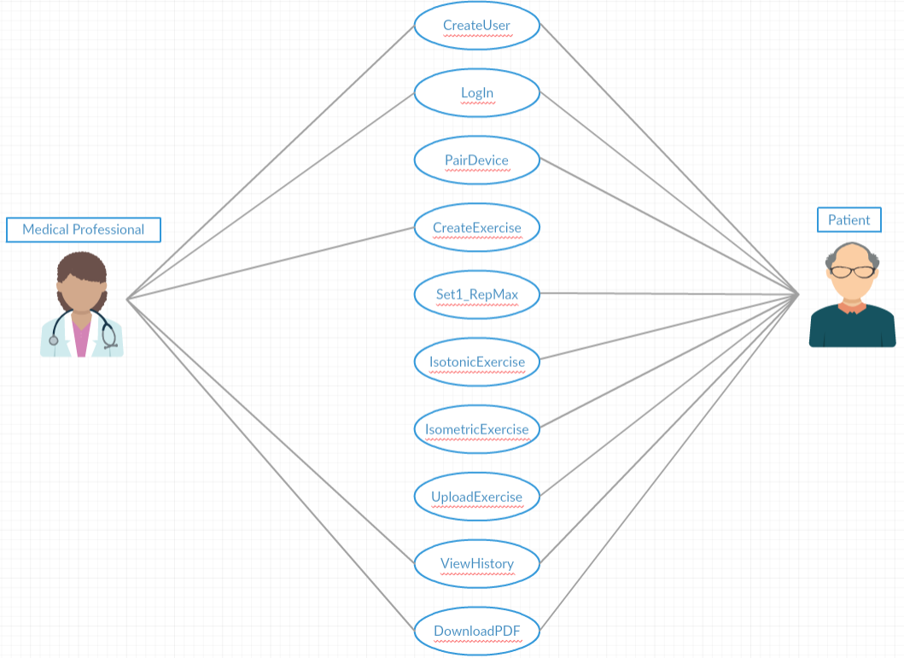

Figure 1: Use Case Diagram

### 

### *Use Case Descriptions*

|  |  |  |
| --- | --- | --- |
| Use Case Descriptions | | |
| UC1 | CreateUser | Patients and medical professionals should be able to make a patient user account from a mobile device using the patient’s EMR number. Medical professionals should be able to make an account which allows them to view their patient’s information. |
| UC2 | LogIn | Patients should be able to log in to the mobile app the first time the app opens and the app should remain logged in on their personal mobile device. Home screen is displayed after successful login. |
| UC3 | PairDevice | Users should be able to connect their mobile device to the exercise ball by selecting from a list of available Bluetooth devices. The app will prompt this when a device is not connected or allow the user to change the connection through settings. |
| UC4 | CreateExercise | Medical professionals should be able to make a patient exercise plan that the patient can work on between appointments. Plans would include specifying the exercise module and the number of times or frequency that the module should be completed during a specified time period. |
| UC5 | Set1_RepMax | The patient requests to set a 1-rep max from the settings screen. The app then prompts the user to squeeze the ball as hard as they can three times and stores the 1-rep max as the average of the three attempts. |
| UC6 | IsotonicExercise | Patients should be able to follow the isotonic exercise module. The program sets various pressure thresholds based on the patients 1 rep max. The program then guides the patient through the exercise routine where the patient squeezes and releases the ball while a counter counts the repetitions for a certain threshold. |
| UC7 | IsometricExercise | Patients should be able to follow the isometric exercise module. The program sets various pressure thresholds based on the patients 1 rep max. The program then guides the patient through the exercise routine where the patient holds the pressure above a threshold for a period of time while a timer counts down. |
| UC8 | UploadExercise | Patients should be able to upload exercise results to the online server upon completion of a session. The user will be prompted to either discard the results or upload them. |
| UC9 | ViewHistory | Patients and medical professionals should be able to view the exercise history and the corresponding results either for specific sessions or aggregate data which will depict different metrics showing progress over time. |
| UC10 | DownloadPDF | The user and clinician can download the Session or aggregate data in the form of a PDF report which can be attached to patient medical records. |

### 

### *Detailed Use Cases*

|  |  |
| --- | --- |
| Use Case: CreateExercise | |
| Use Case ID | UC4 |
| Brief Description | Medical professionals should be able to make a patient exercise plan that the patient can work on between appointments. Plans would include specifying the exercise module and the number of times or frequency that the module should be completed during a specified time period. |
| Primary Actors | Clinician/Medical Professional |
| Secondary Actors | Patient |
| Precondition(s) | 1. Clinician/Medical Professional has an account 2. Patient has an account |
| Main Flow | 1. Medical Professional selects one or modules to be completed 2. Medical Professional selects the frequency or number of times the exercise should be completed 3. Medical Professional saves the exercise plan 4. Medical Professional assigns the exercise plan to selected patients |
| Postcondition(s) | 1. The user is reminded about new or incomplete exercises through push notifications |
| Alternative Flow | None |

|  |  |
| --- | --- |
| Use Case: IsotonicExercise | |
| Use Case ID | UC6 |
| Brief Description | Patients should be able to follow the isotonic exercise module. The program sets various pressure thresholds based on the patients 1 rep max. The program then guides the patient through the exercise routine where the patient squeezes and releases the ball while a counter counts the repetitions for a certain threshold. |
| Primary Actors | Patient |
| Secondary Actors | None |
| Precondition(s) | 1. Patient is logged in. 2. Patient has an isotonic exercise module assigned to them. |
| Main Flow | 1. Program prompts user to set a new 1-rep max or use a saved one if available. 2. Program sets threshold at 40% of the 1 rep max 3. User squeezes and releases the exercise ball 10 times above the threshold. 4. Program repeats steps 2 and 3 using 60% and 80% thresholds. 5. Program asks the user whether or not they would like to upload the results or discard them. |
| Postcondition(s) | 1. Exercise is marked as complete. |
| Alternative Flow | None |

## 

## Requirement Traceability Matrix

|  |  |  |  |  |  |  |  |  |  |  |  |
| --- | --- | --- | --- | --- | --- | --- | --- | --- | --- | --- | --- |
| Use Cases | | | | | | | | | | | |
|  |  | UC1 | UC2 | UC3 | UC4 | UC5 | UC6 | UC7 | UC8 | UC9 | UC10 |
| FR1 | X | X |  |  |  |  |  |  |  |  |
| FR2 | X |  |  |  |  |  |  |  | X | X |
| FR3 | X | X |  |  |  |  |  |  |  |  |
| FR4 |  | X |  |  |  |  |  |  |  |  |
| FR5 |  |  | X |  |  |  |  |  |  |  |
| FR6 |  |  | X |  |  |  |  |  |  |  |
| FR7 |  |  | X |  |  |  |  |  |  |  |
| FR8 |  |  | X |  |  |  |  |  |  |  |
| FR9 |  |  |  |  | X | X | X |  |  |  |
| FR10 |  |  |  |  | X | X | X |  |  |  |
| FR11 |  |  |  | X |  |  | X |  |  |  |
| FR12 |  |  |  | X |  | X |  |  |  |  |
| FR13 |  |  |  |  | X |  |  |  |  |  |
| FR14 |  |  |  |  | X | X | X |  |  |  |
| FR15 |  |  |  |  | X |  |  |  |  |  |
| FR16 |  |  |  |  | X |  |  |  |  |  |
| FR17 |  |  |  | X |  | X | X |  |  |  |
| FR18 | X | X |  |  |  |  |  |  |  |  |
| FR19 |  |  |  |  |  |  |  |  | X | X |
| FR20 |  |  |  |  |  |  |  |  | X | X |
| FR21 |  |  |  |  |  | X | X |  |  |  |
| FR22 |  |  |  |  |  | X | X |  |  |  |
| FR23 |  |  |  |  |  | X | X |  |  |  |
| FR24 |  |  |  |  |  |  |  | X |  |  |
| FR25 |  |  |  | X |  |  |  |  |  |  |
| FR26 |  |  |  |  |  | X | X |  |  |  |

## Initial Snapshots

The following images are prototypes of the patient views of our application. The medical professionals will have additional functionalities, which will include creating exercises and monitoring patients. Figure 2 shows the initial login screen, which accepts the username and password. Alternately, it has the option to create a new account. The application will then detect the bluetooth connection. If there is no connection, the user will be prompted to connect one as seen in Figure 3. The user will select the device from a list of detected devices. (Fig. 4)

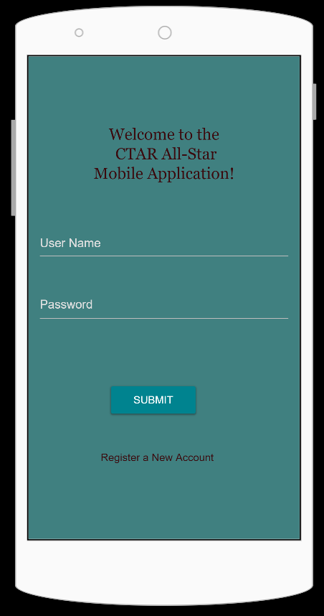 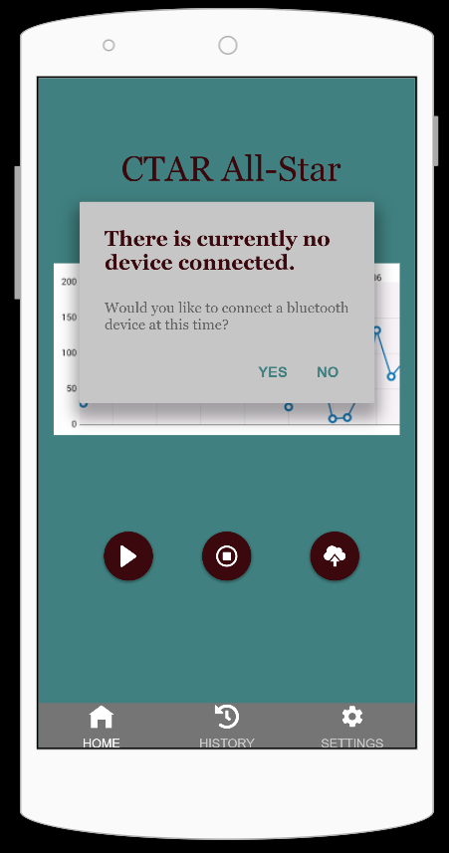 …...Figure 2: Login Screen Figure 3: Bluetooth Detection

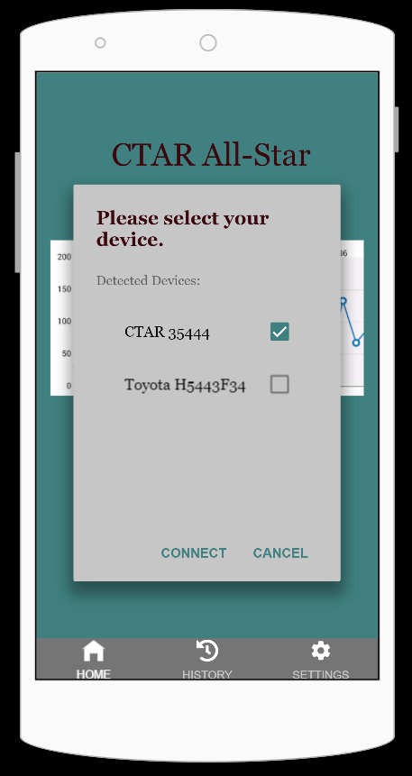 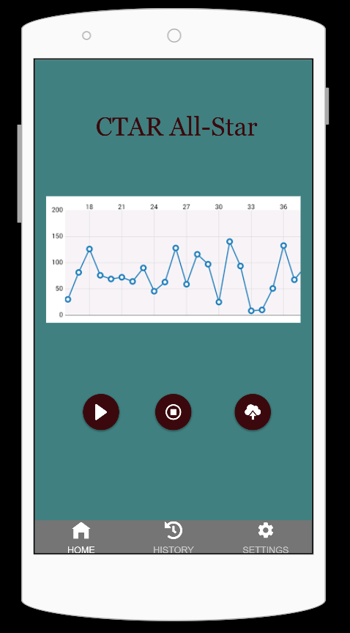

Figure 4: Bluetooth Device Select Figure 5: Vertical Home Screen...

After the application is open and connected to a CTAR device, the home screen is presented. It will change with the mobile device, capable of a vertical (Fig. 5) or a horizontal orientation (Fig. 6), which will be more desirable for viewing a larger real-time graph. This screen will display the graph and buttons to start, stop and save the latest session.

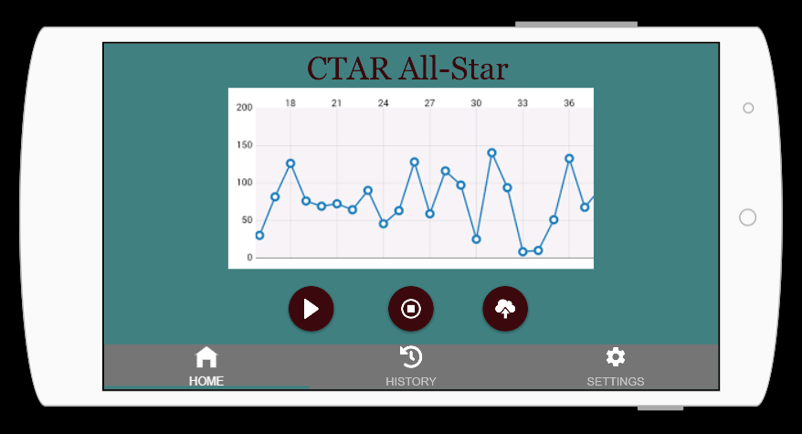

Figure 6: Horizontal Home Screen

The navigation bar on the bottom of the application will allow the users to switch to the history page (Fig. 7) where they can view their personal session history and select those they would like to view in more detail. They can filter their search of the database elements by pressing the filter button. This will allow them to select certain attributes to narrow down their results.

The settings screen seen in Figure 8, can also be accessed from the navigation bar. Here the user can set a timer, train the application to determine their 1-Rep Max threshold, and make many other modifications.

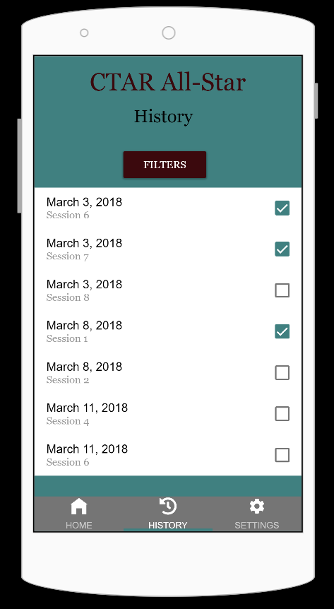 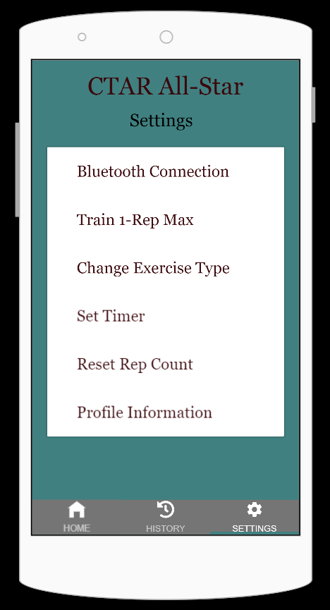

Figure 7: History Database Figure 8: Settings Menu

## Glossary

|  |  |
| --- | --- |
| 1. | **1-Rep Max**: The maximum amount of pressure a person can possibly exert for one repetition. Sometimes an average of three repetitions at max strength is used to determine this. |
| 2. | **Bluetooth**: A standard for the short-range wireless interconnection of mobile phones, computers, and other electronic devices. |
| 3. | **Cross-Platform**: Able to be used with different software packages such as iOS or Android. |
| 4. | **CTAR**: Chin Tuck Against Resistance. An exercise used in rehabilitation that strengthens the suprahyoid muscles in the neck. |
| 5. | **Database**: A structured set of data held in a computer, especially one that is accessible in various ways. |
| 6. | **Dysphagia**: A condition which makes it difficult or painful to swallow and is common in stroke victims and the elderly. |
| 7. | **Electronic Medical Record (EMR)**: A digital version of the traditional paper-based medical record for an individual. Represents a medical record within a single facility such as a doctor’s office. |
| 8. | **HIPAA**: Health Insurance Portability and Accountability act of 1996 is the United States legislation that provides data privacy and security provisions for safeguarding medical information. |
| 9. | **Isometric**: an exercise or a program of exercises to strengthen specific muscles or shape the figure by pitting one muscle or part of the body against another or against an immovable object in a strong but motionless action, as by pressing the fist of one hand against the palm of the other or against a desk. (Dictionary) |
| 10. | **Isotonic**: an exercise or a program of exercises to increase muscular strength, power, and endurance based on lifting a constant amount of weight at variable speeds through a range of motion. (Dictionary) |
| 11. | **Pneumatic Ball**: A ball that is operated by putting air or gas under pressure. |
| 12. | **Real-Time Graph**: A graph that depicts the input data as it is received. |
| 13. | **Speech Pathology**: The study and treatment of speech and language problems. |
| 14. | **Surface Electromyography (sEMG)**: The electrical activity of individual muscles or muscle groups is detected, amplified, and analyzed by a computer. |
| 15. | **Xamarin**: A cross-platform application development tool owned by Microsoft. |

## List of References

### Websites

*Arduino and HC-05 Bluetooth Module Tutorial (website) Retrieved from* [*https://www.raywenderlich.com/2295-arduino-tutorial-integrating-bluetooth-le-and-ios*](https://www.raywenderlich.com/2295-arduino-tutorial-integrating-bluetooth-le-and-ios)

This website gives an introductory tutorial on how to configure an arduino to communicate with an iOS device via Bluetooth. It lists the hardware needed, a great deal of information relating to code on the arduino side, details on wiring, and some information on development of the mobile app for iOS.

*Dysphagia (website) Retrieved from* [*https://www.nidcd.nih.gov/health/dysphagia*](https://www.nidcd.nih.gov/health/dysphagia)

This website gives a relatively detailed overview of what dysphagia is, the causes of dysphagia, and problems that can arise as a result of dysphagia. Additionally an explanation of how swallowing is supposed to work and the treatments available for dysphagia are explained.

*Visual Studio Tools for Xamarin (website) Retrieved from* [*https://docs.microsoft.com/en-us/xamarin/xamarin-forms/index*](https://docs.microsoft.com/en-us/xamarin/xamarin-forms/index)

This website is the official Microsoft site for Xamarin.Forms, the cross platform mobile application framework we decided to use for our project. It thoroughly explains the fundamentals and offers guides for getting started, user interfaces, cloud services and deployment and testing. It also offers links to several books and code samples.

### Articles

*Bai, P., Li, J., Li, Y., Duan, X. “Application of Mobile Bluetooth based on Human Physiology Parameters Wireless Sensor” IEEE International Conference of Consumer Electronics-China, 2016.*

This paper explores the communication needs of wireless medical sensors. The software should be fast and easy to use and reliable. It discusses the use of mobile applications in real time and describes the implementation of the software and the wireless sensors data interface. It also explains how the wireless sensor and mobile bluetooth communicate.

*Caulfield, B., Blood, J., Smyth, B., Kelly, D. “Rehabilitation Exercise Feedback on Android Platform.” CLARITY Center for Sensor Web Technology, 2011.*

This article has a solution for the ineffectiveness of in home Physical Therapy. An exergame environment, VITFIZ, provides an affordable, interactive and real-time in home Physical Therapy solution for Android. Users of this device found it less boring and easier to distract themselves from pain management, resulting in successful Physical Therapy. Overall, this paper supports the need for interactive mobile applications for physical rehabilitation.

*Vasconcelos, A., Correia, C., Nunes, F., Carvalho, A “Mobile, Exercise-agnostic, Sensor-based Serious Games for Physical Rehabilitation at Home.” Proceedings of the Twelfth International Conference on Tangible, Embedded, and Embodied Interaction, pp 271-278, 2018.*

This paper describes several games that were created for physical rehabilitation. These games ensure correct execution of exercises outside the clinic. They are displayed on a smartphone and use a wearable device. The games are interesting and focus on contraction and relaxation times and repetitions.

### Publications

*bin Aftab, M.U. Building Bluetooth Low Energy Systems. Birmingham, UK: Packt Publishing. 2017.*

This book is an in depth look into bluetooth systems. It focuses on low energy bluetooth and covers many topics, including the Internet of Things, hardware, software and debugging tools. It also explains building a BLE central and peripheral communication system, low energy beacons, and mesh technology. It walks you through how to implement a bluetooth gateway using a Raspberry Pi 3 and concludes with a talk about the future of Bluetooth Low Energy.

### Cited in This Paper

Glossary Definitions were retrieved from [www.dictionary.com/](http://www.dictionary.com/)

## Contributions of Team Members

### Terri Heglar

Terri has contributed 21 hours to this portion of the project. She created the initial template, table of contents and wrote the rough draft of the stakeholders’ interviews summary. She built the framework for the tables and images in the Technical Requirements Specification, Use Cases Modeling and Requirement Traceability Matrix sections. She wrote a lot of the functional requirements and some of the glossary terms. She made the prototype images and wrote the Initial Snapshots section rough draft. She wrote two article reference summaries and one website summary. Additionally, she helped clean up and finalize the whole paper.

### Austin Yount

Austin has contributed 16 hours to this portion of the project. He wrote the introduction, the Non-Functional Requirements, a large portion of the Functional Requirements, a significant portion of the use cases, half of the detailed use cases, drew the use case diagram, found and wrote several publication descriptions, and final editing/formatting.

### Andrew Penrose

Andrew has contributed 12.5 hours to Project Part II. He wrote the high level business requirements and the glossary definitions. He helped: brainstorm the Use Case diagram, fill out the requirement traceability matrix, and work on the reference section. He also added to the introduction and worked on formatting and general editing. Finally, he was a part of the interviewing process.